Navarre London Limited
PAS 2050 Carbon Reduction Plan

PAS 2050 process notes and definitions

Scoping – this involves describing our product or service being assessed and mapping its lifecycle, from raw material through to consumption and disposal.

The Greenhouse Gas Protocol splits greenhouse gas emissions into three categories: scope 1, scope 2, and scope 3.

Scope 1 is direct emissions caused by any process or activity by the company that causes greenhouse gas emission. E.g., is in the form of fuels burnt on-site or by company-owned vehicles. Other forms are leaks of refrigerant gases (for example from refrigerators or air conditioning) or any emissions from industrial processes. .

Scope 2 is indirect emissions caused by purchasing energy (from sources we do not own or control). Electricity, heat.

Scope 3 emissions are all the indirect emissions that occur because of our business activity. For example:

- waste (decomposing waste emits greenhouse gases)
- emissions related to any goods or services purchased (for example any fuel emitted transporting them)
- employees commuting to and from work.

Data collection – data is collected on emissions throughout the product or service lifecycle. This involves engaging with raw material suppliers and supply chain partners to collect data on all relevant emissions.

Footprint calculations – the collected data will be sorted and applied to arrive at a carbon footprint calculation, using relevant sources.

Interpreting results and driving reductions – the data collection and footprint calculation enable emissions hotspots to be identified within a product or service’s lifecycle – providing target areas for emissions reduction.

- Executive Summary

Navarre London Limited is committed to achieving Net Zero Emissions by 2050.

We are aware that reducing our Greenhouse Gas Emissions represents significant benefits for us, our customers, suppliers and the wider community.

Our Carbon Reduction Plan covers the strategies for Navarre London Limited's ongoing commitment to the management and reduction of our business-related carbon emissions.

The plan will cover NLL's baseline year information, setting clear targets for reducing Greenhouse Gas (GHG) emissions over key timeframes and listing our planned projects to achieve carbon net zero by 2050.

While some of these achievements will be achieved through behavioural change, it is noted that, where funding is needed, it will be accessed in collaboration with our Clients to take these projects to the right outcome.

As a largely administration-based business, we will still be pushing our business and working with all of our employees and contractors to embrace this plan and work collaboratively to achieve the overall goal of Carbon Net Zero by 2050.
The points below show the journey we are taking:
- NLL aims to reduce its GHG emissions by 50% by 2040 based on its 2024 baseline.
- NLL’s GHG baseline emissions has been established in 2024.
- Several staff training and behaviour change projects have been identified that will work to achieve net zero emissions by 2050.
- Working remotely / from home initiatives will cut our carbon footprint further.
- Several staff training and behaviour change projects have been identified that will work to achieve net zero emissions by 2050.
- Carbon sequestration will also be utilised to attain net zero by 2050.

- Meeting the reporting requirements

This Carbon Reduction Plan is completed in compliance with PAS2050 This document will be reviewed and updated at a minimum annually. It will reflect any changes in organisational structure and take account of the efforts made to reduce our emissions over time to achieve net zero by 2050.

  - Our low carbon vision.

As an organisation, NLL is committed to integrating sustainable development into everyday practice by minimising environmental impact wherever possible.

During the process of developing this Carbon Reduction Plan, a number of key areas have been selected that will allow us to demonstrate reductions in the carbon emissions generated by our activities in the Interiors fit our and refurbishment industry.

3. Method of data collection:

The organisation reports on all sources of carbon emissions over which it has operational control. The organisation is deemed to have operational control over a service if it has full authority to introduce and implement its operating policies.

4.0 Navarre London Limited

Navarre London Limited is an interior fit out and refurbishment contractor. The calculation of the footprint for Navarre London Limited is based upon accurate recording of emissions as follows:

5.0 Baseline Emissions Footprint
Baseline emissions are a record of the greenhouse gases that have been produced in the past and were produced prior to the introduction of any strategies to reduce emissions. Baseline emissions are the reference point against which emissions reduction can be measured.

Baseline Year: 2024
Additional Details relating to the Baseline Emissions calculations.
Baseline year emissions: 2024
EMISSIONS | TOTAL (kgCO₂e)
Scope 1 | 0 (Navarre London Limited operates no production facilities, nor does it have a vehicle or van fleet.
Scope 2 | Energy all offices - 360.78 kgCO2e
Scope 3  (Included Sources) | 18554.02 kgC02e  (Personal transport)
Total Emissions | 20,669.20 kgC02e

6.0 Current Emissions Reporting

Reporting Year: 2025
EMISSIONS | TOTAL (kgCO₂e)
Scope 1 | N/A
Scope 2 | Being compiled
Scope 3  (Included Sources) | Being compiled
Total Emissions | TBC

7.0 Carbon Reduction Projects –

7.1 Completed Carbon Reduction Initiatives

The following environmental management measures and projects have been completed or implemented.

- ISO14001:2015 (Environmental Management)
- Working from Home Initiative
- ECO Vadis Gold Standard
- Planting of 206 mango trees in Malawi thus far (as of Feb 2025)

In the future we will implement further measures including:

- Carbon Sequestration
- Switching over to Carbon Neutral Energy by the end of 2025.

8.0 Declaration and Sign Off
This Carbon Reduction Plan has been completed in accordance with PAS 2050 and associated guidance and reporting standard for Carbon Reduction Plans.
Emissions have been reported and recorded in accordance with the published reporting standard for Carbon Reduction Plans and the GHG Reporting Protocol corporate standard and uses the appropriate Government emission conversion factors for greenhouse gas company reporting.
This Carbon Reduction Plan has been reviewed and signed off by the board of directors.
Managing Director
Gary Fox
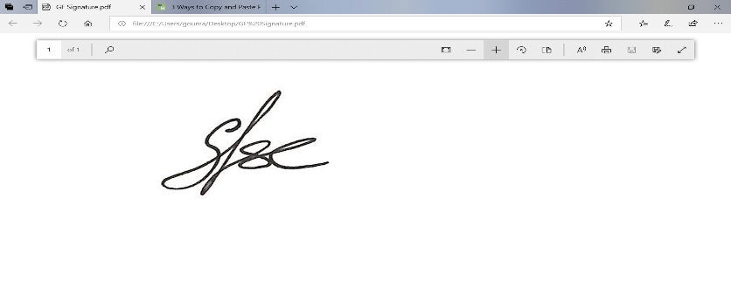

Date: 24.03.2025

